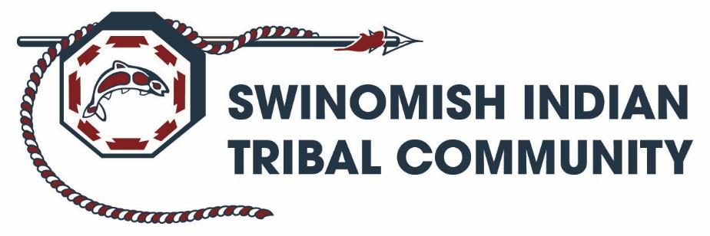

Human Resources
11404 Moorage Way
La Conner, WA 98257
Phone (360)466-7353 | Fax (360)466-1348

Is this a Testing Designated Position as described in the Drug and Alcohol-Free Workplace Policy ? | N
Do the duties and responsibilities of this position involve regular contact with, or control over, Indian children or elders ? | N
Indian Preference in Hiring shall apply to Swinomish Indian Tribal Community job opportunities.

JOB TITLE: Environmental Science Communicator/ Outreach Specialist 1

DEPARTMENT: Environmental Protection (DEP) / Natural Resources

PATY RATE: $33.94 - $34.52/HOUR

Open until filled, app review starts 1/29/2026

POSTION SUMMARY
The Environmental Outreach Specialist is responsible for performing science communication and outreach activities for the Department of Environmental Protection (DEP). The incumbent is responsible for coordinating with DEP and SITC staff to develop and organize environmental and science outreach materials for print and/or on-line outlets, and coordinate outreach events for the different audiences relevant to the DEP. This position is supervised by the Environmental Education (Indigenous Science) Manager – Assistant Director.

ESSENTIAL DUTIES AND RESPONSIBILITIES
- Programmatic Outreach duties:
  - Content Strategy: Manages, develops, and implements the DEP outreach strategy in coordination with senior staff;
  - DEP science content development, writing, and design:
    - Manages outreach by coordinating and gathering materials and content from programs and staff in the DEP to develop and deliver outreach materials, activities, and content for social media to the Community in a cohesive and reliable manner.
    - Coordinates with Swinomish Communications department and other approvals regularly for consistency in the designs, graphics, and messaging for Swinomish DEP outreach in the Qyuuqs newsletter, and other print or on-line outlets;
    - Prepares and/or assists DEP staff in drafting internal technical reports and/or multimedia presentations.
  - Community Engagement: Coordinates DEP outreach at community engagement events; examples including community dinners, science workshops, conferences, and other relevant gatherings;
- May implement and manage 1-3+ DEP projects, grants, and/or contracts as directed by the senior staff including; environmental protection/science projects, 0grant writing for on-going and new applications for environmental outreach grants, researching available grants, drafting work plans & budgets for grants, drafting work scope and tracking budgets for contracts, and grant reporting support.
- Develops and researches new outreach opportunities that can benefit the DEP as well as the Swinomish Tribe in relation to science outreach. Additional research for effective and creative science communication methods to focus on the varied demographics of the Swinomish peoples;
- Other duties as assigned. The specific job duties described above are intended to be primary examples of assigned tasks and not meant to be exclusive. Employees are expected to perform any reasonable duties and tasks assigned to them by their supervisor or department director.

MINIMUM REQUIREMENTS AND QUALIFICAITONS
- Bachelor’s degree with college coursework in design, electronic media, web page design and publishing, science communications, and public relations;
  - 2 years’ experience in the field of outreach, and design, or comparable job experience;
  - An equivalent combination of education and experience in design, electronic media, web page design and publishing, science communications, and public relations may be considered;
- Physical ability to work in the field as well as work in an office setting;
- Valid Driver’s License; or ability to earn license within first 1-3 months of employment.
- Ability to work independently, efficiently, reliable, self-motivated, and able to work in a team;
- Proficient with software programs including Microsoft Word and Outlook to compose communications and write social media posts, outreach materials, memos, and reports;
- Familiarity using design and publishing programs such as Adobe, Canva, Lucidpress;
- Commitment to environmental protection and sensitivity to tribal issues.

REQUIRED KNOWLEDGE, SKILLS AND ABILITIES
- Proficient with communications and online software including: Zoom, MS Teams, Canvas, etc. to plan, host, facilitate, and implement outreach events;
- Excellent verbal and written communication and interpersonal skills;
- Familiarity with Swinomish cultural teachings

WORK ENVIRONMENT AND TIME COMMITMENT
- Work schedule is 40 hours per week. This is a full-time position.
- Work is performed both in an office setting indoors and outdoors. Must be physically able to work in the field including, bending, lifting, walking over rough terrain, wading in streams, wetlands, and at beaches.

EMPLOYMENT CONDITIONS
The Personnel Policies and Procedures of the Swinomish Indian Tribal Community apply to all employees. This position is considered to be a non-exempt “standard hour” position. All offers of employment are contingent on the successful completion of a drug and alcohol screening. If the position involves regular contact with or control over children or elders, then a successful applicant must also meet minimum standards of character based on a criminal background check.

TRIBAL PREFERENCE
Indian Preference in hiring shall apply to Swinomish Indian Tribal Community job opportunities. Employees working with vulnerable populations will be required to submit to drug and alcohol screening as needed.

Employee ___________________________________________ Date: __________________

Supervisor: ___________________________________________ Date: ___________________

