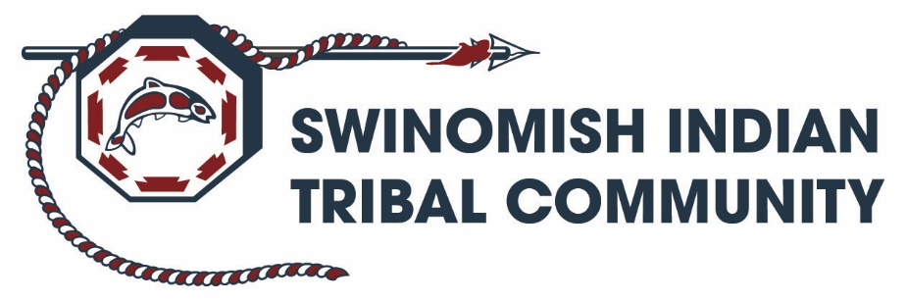

Human Resources
11404 Moorage Way
La Conner, WA 98257
Phone (360)466-7353 | Fax (360)466-1348

Is this a Testing Designated Position as described in the Drug and Alcohol-Free Workplace Policy ? | N
Do the duties and responsibilities of this position involve regular contact with, or control over, Indian children or elders ? | N
Indian Preference in Hiring shall apply to Swinomish Indian Tribal Community job opportunities.

JOB TITLE: Vegetation Specialist

DEPARTMENT: Environmental Protection / Natural Resources

PAY RATE: $24.33 - $29.95/Hr DOQ

APPLICATION REVIEW STARTS: JANUARY 26th, 2026

POSITION SUMMARY:
The Vegetation Specialist is responsible for providing programmatic, field, technical, and administrative support for the Swinomish Department of Environmental Protection’s Forestry, Camas, and Noxious Weed Control Programs, by supervising vegetation field activities and data collection. The required work includes plant identification, vegetation field crew leadership and participation using a full range of vegetation management techniques, and fieldwork tracking and reporting. The position is supervised by the Forester and provides general oversight to 3-5 technical environmental staff and/or seasonal technician or intern in vegetation-related activities.

ESSENTIAL DUTIES AND RESPONSIBILITIES
- Programmatic duties include managing technicians in vegetation management in the field for Forestry, Camas, and Noxious Weed Control Programs, collection and data management of vegetation control data; and, basic data analysis and reporting:
  - Manage 3-5 technical staff by serving as field lead for:
    - reforestation and traditional plant restoration efforts, including site preparation, seeding, planting, weed control, and pruning timber seedling replanting and restoration;
    - forest relief treatments including brush and small timber removal;
    - implementing a full range of integrated weed management techniques including use of herbicides, manual removal, and biological control of weed species in the uplands, freshwater wetlands, and intertidal areas of the Swinomish Reservation; and,
    - Other vegetation management activities as directed by the Forester;
  - Assisting other Tribal departments including Swinomish Utility Authority, Land Management, Port Authority, Housing, Planning and Community Development in controlling undesirable vegetation for habitat health/restoration on the Swinomish Reservation;
  - Independently preparing vegetation management data collection field forms using GPS and other mobile technology-based tools;
  - Independently preparing and maintaining herbicide mixes, use records, and storage areas with strict attention to safety protocols;
  - Operates ATVs, small vessels, tractors, and powered spray equipment and tools in execution of vegetation managment duties;
- Implements and manages 2-5+ DEP programmatic grants and contracts as directed by the Forester including;
    - Assist in drafting work plans & budgets for on-going and new applications for grants/funds;
    - Coordinating program spending;
    - Assist with project management for projects and contracts; and,
    - Prepares draft grant reports for Forester review including maps and tables documenting vegetation work.
- Support special studies and research projects to fill data gaps and identify potential noxious weeds issues or impacts:
    - Data collection and preliminary data analysis; and,
- Technical reporting and review.
- Contributes to reports, presentations, and research proposals for internal and external audiences.
- Assists with outreach and environmental education to the public and Tribal Community.
- Employee may be expected to perform a wide range of office and field duties from time to time. Such Duties may or may not be related to their regular responsibilities.

MINIMUM QUALIFICATIONS
- Bachelor’s degree with college coursework in environmental, physical, or natural science, or other discipline appropriate to the position, AND
  - 2 years of experience at the Technician 1 level or comparable job experience;
  - Any combination of the above education and professional experience that provides 5 years of comparable responsibility in vegetation management and data collection to acquire the necessary knowledge, skills, and abilities to perform the work;
- Demonstrated experience with operation and maintenance of equipment, materials, and procedures used in vegetation managment;
- Demonstrated experience in herbicide application;
- Demonstrated experience in tracking and reporting field work;
- The employee must be able to safely operate and maintain a variety of light and heavy equipment (small gas powered tools, pumps, ATVs, powered sprayers, vessels, and tractors);
- Physical ability to work in the field including wading in streams, wetlands, and at beaches; and work from a boat during inclement weather as well as work in an office setting;
- Valid Washington State Driver’s License;
- Within 6 months of hire, the employee must obtain and retain certification as a Washington State pesticide applicator (Public Operator) with the appropriate endorsements required for control of noxious weeds on the Swinomish Reservation. This includes, at a minimum, the aquatic pesticide applicator endorsement;
- Within 1 year of hire, employee must obtain and retain a 40-hour HAZWOPR certificate, renewed on an annual basis.

REQUIRED KNOWLEDGE, SKILLS AND ABILITIES

- Ability to independently implement detailed data collection and data quality assurance/quality control procedures;
- Ability to work independently and efficiently and reliable and self-motivated, and able to work in a team;
- Practical field experience and data collection using GPS or mobile technology;.
- Familiarity with Swinomish or other Tribal governments or communities IS DESIRED.

WORK ENVIRONMENT AND TIME COMMITMENT

- Work schedule is 40 hours per week. This is a full-time position.
- Tasks are performed in office setting and outdoors in the field, over rough ground.
- Work may be performed under highly stressful conditions, and may involve extended periods of sitting, standing or walking, or wading in cold water.

EMPLOYMENT CONDITIONS

The Personnel Policies and Procedures of the Swinomish Indian Tribal Community apply to all employees. The position is considered to be a non-exempt position. All offers of employment are contingent on the successful completion of a drug and alcohol screening. If the position involves regular contact with or control over children or elders, then a successful applicant must also meet minimum standards of character based on an extended criminal background check.

Employee: ____________________________________ Date: ____________________

Supervisor: ____________________________________ Date: ____________________

