2022 Hedges Visiting Scholar: Dr. Tessa Hill, UC Davis
4:00 – 5:30 p.m.
Location: Hitchcock 132

Speaker: Dr. Tessa Hill, University of California Davis
Title: “Ocean at the edge of the map: Science and stories from a changing sea”
Host: Chemical Oceanography graduate students
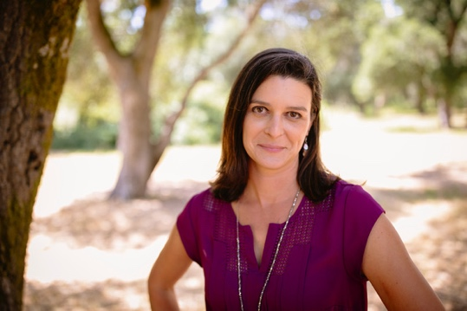
About: Dr. Hill is a professor at UC Davis and is a research expert in how climate change and ocean acidification impact marine ecosystems and West Coast communities. She has a particular interest in integrating research with policy and decision making. She is visiting as part of the Hedges Visiting Scholar Program, which provides funding to UW chemical oceanography graduate students to invite prominent researchers from outside the university to visit with students and faculty and to present a departmental seminar.

