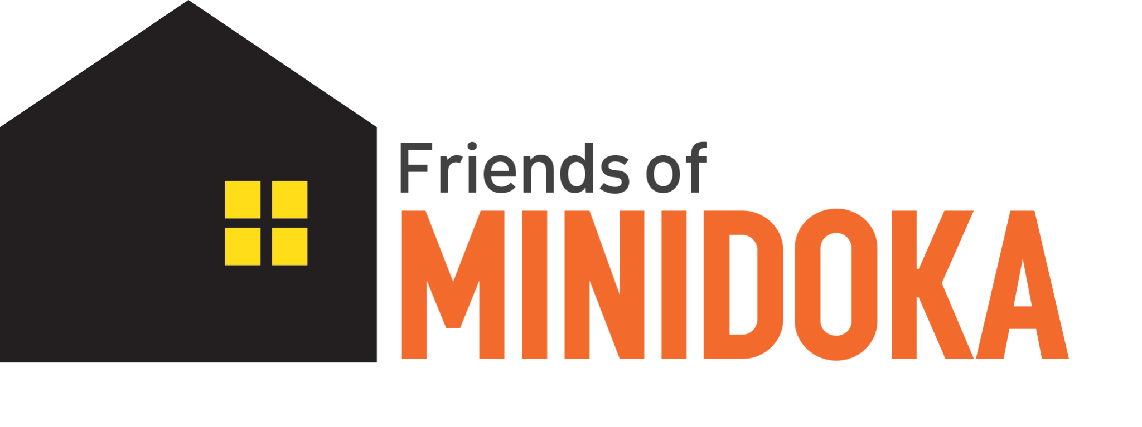

**Exhibit/Research Undergraduate Intern**

**Summer 2023**

**Background**

124,000 Japanese Americans were forcibly removed from the West Coast and incarcerated at concentration camps during WWII. 13,000 men, women, and children from Alaska, Oregon and Washington were incarcerated at Minidoka War Relocation Center in Jerome, Idaho, which is now the Minidoka National Historic Site, a unit of the National Park Service. Friends of Minidoka is the nonprofit philanthropic and educational organization that supports Minidoka NHS through protection and preservation of the lessons and legacy of the incarceration story.

**Job Description**

The Friends of Minidoka Exhibit intern will perform a variety of research, writing, and related activities to create an online exhibit centered around their research. This intern will choose a research topic/question and create an online exhibition to be hosted on Friends of Minidoka’s website and be based on artifacts, documents, and photos available through online and in-person collections. Resources include Densho, the National Archives, the Robert C. Sims Collection at Boise State University, and physical items managed by the National Park Service.

This internship requires a strong interest in history and civil liberties as well as excellent written and verbal communication. Students will conduct research using primary and secondary sources to create the online exhibit. Students will also present their research (virtually) to Friends of Minidoka and National Park Service staff. Internship takes place over the summer semester. Two to three credit hours (90-135 hours) are preferred. Hourly salary of $16.00/hour up to 135 hours total.

**Qualifications**

* Currently enrolled undergraduate college student, preferably located in Idaho.
* Demonstrated interest in civil liberties and the Japanese American incarceration experience.
* Excellent written and verbal communication.
* Knowledge of historical research processes.
* Attention to detail and willingness to learn.
* Demonstrated ability to foster an atmosphere of diversity and inclusion consistent with the Friends of Minidoka’s aims.
* Must pass a criminal background check.

**Responsibilities**

* Bi-weekly meeting with Internship Coordinator.
* One visit (approximately 1 to 2 days) to Minidoka NHS and Collection storage facility. Mileage, lodging, and per diem expenses at the federal reimbursement rate to and from the site will be covered by FOM.
* Research one primary research topic as discussed with the Internship Coordinator.
* Products:
  + One online exhibition to highlight the research conducted about the specific topic.
    - Includes written interpretation with each “object” and how the object relates to the larger theme.
      * 5-10 objects for the exhibition.
      * Objects can be photographed physical objects from the Minidoka NHS Collection, or digitized documents and photographs.
  + Short article for Friends of Minidoka’s monthly newsletter and 3 to 4 social media posts about the exhibit.
  + 15 minute presentation to Friends of Minidoka and NPS staff about your research and your experience researching and writing (10 minute presentation, 5 minute Q&A).

**Orientation**

* Meet with Friends of Minidoka Internship Coordinator and Executive Director.
  + Agree upon topics for research and timeline for products.
  + Complete administrative paperwork.
* Training
  + Historical background on the Japanese American experience.
  + Online research training.

**Supervision**

* Reports to Friends of Minidoka Internship Coordinator.
* Reports to Friends of Minidoka Executive Director for administrative issues.

**Physical requirements and working conditions**

* Work is performed primarily indoors and may involve sitting for long periods of time.
* Successful applicants will need to comply with COVID-19 safety mitigations including but not limited to wearing masks, observing physical distancing, and enhanced sick policies.
* Ability to access a computer, laptop, or mobile device capable of video conferencing and internet access for research.

**Application**

* Must be a current undergraduate student, preferably in Idaho.
* Email the completed [application](https://docs.google.com/document/d/1wGcLXdpMwyYIkq6jI8lBkl_LFqYWG3JNyTbYSpQoGbs/edit?usp=sharing) and a resume by May 26, 2023 to [info@minidoka.org](mailto:info@minidoka.org) and [camille@minidoka.org](mailto:camille@minidoka.org).

Friends of Minidoka does not and shall not discriminate on the basis of race, color, religion (creed), gender, gender expression, age, national origin (ancestry), disability, marital status, sexual orientation, or military status, in any of its activities or operations. These activities include, but are not limited to, the appointment to and termination from its Board of Directors, hiring and firing of staff or contractors, selection of volunteers, selection of vendors, and providing of services.

Friends of Minidoka is an equal opportunity employer. We shall not discriminate and will not discriminate in employment, recruitment, Board membership, advertisements for employment, compensation, termination, upgrading, promotions, and other conditions of employment against any employee or job applicant on the basis of race, color, religion (creed), gender, gender expression, age, national origin (ancestry), disability, marital status, sexual orientation, or military status, or for any other discriminatory reason.