**HOW DO THEY DO IT? WHAT WERE THEY THINKING?**

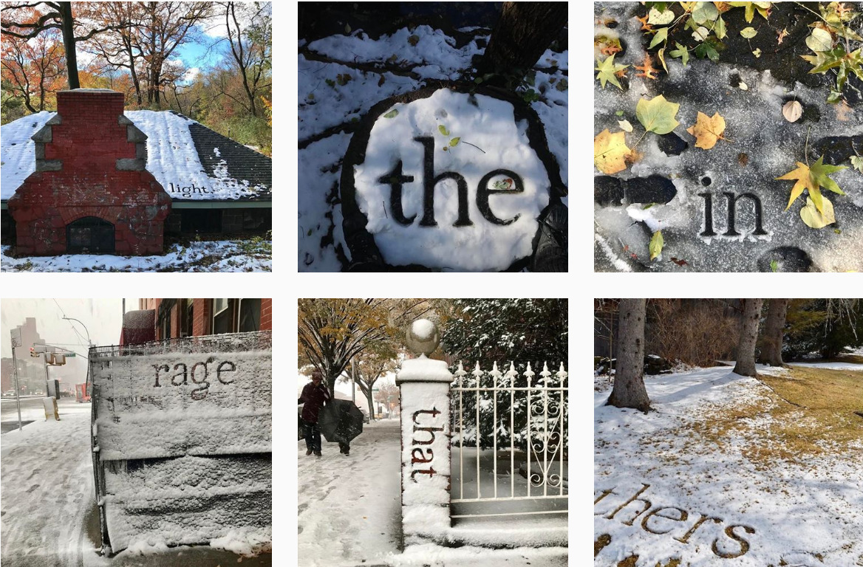

Photo credit: Shelley Jackson, as @snowshelleyjackson on Instagram

**WRITERS ON WRITING (ENGL 285)**

Spring 2022 Tues/Thurs 12:30-2:20 Hybrid Professor Maya Sonenberg

* VLPA, 5 Credits
* Lectures and Readings by UW Creative Writing faculty and other fiction writers, poets, and nonfiction writers
* Opportunities for small group work & feedback on your writing
* Assignments: brief responses to the talks, short creative writing exercises
* Questions? Ask me! [mayas@uw.edu](mailto:mayas@uw.edu)
* More info about me: <https://mayasonenberg.com/> & <https://english.washington.edu/people/maya-sonenberg>

Student Endorsements

* “If I had taken this class as a 1st year, I would be a creative writing major. It’s SO COOL.”
* “In other creative writing classes, it can be intimidating if you have little to no experience…. But this course leaves more room for rough drafts, so it’s a great intro.”
* “The variety of prompts & speakers did a great job of pulling me just slightly out of my comfort zone, enough to learn quite a bit without being stressed out.”
* “Everyone should be able to benefit from creative writing—from self-exploration to enhanced perception of the world to increased overall writing ability—they should, of course, take this class.”
* “Eye-opening in many ways—especially the different stories being shared.”